When we have too many features in the datasets and we want to develop a prediction model like a neural network will take a lot of time and reduces the accuracy of the prediction model.

We need to make use of the Boruta algorithm and is based on random forest.

**How Boruta works?**

Suppose if you have 100 variables in the dataset, each attributes creates shadow attributes, and in each shadow attribute, all the values are shuffled and creates randomness in the dataset.

Based on these datasets will create a classification model with shadow attributes and original attributes and then assess the importance of the attributes.

**Load Libraries**

library(Boruta)

library(mlbench)

library(caret)

library(randomForest)

**Getting Data**

data("Sonar")

str(Sonar)

The dataset contains 208 observations with 61 variables.

'data.frame':     208 obs. of  61 variables:

 $ V1   : num  0.02 0.0453 0.0262 0.01 0.0762 0.0286 0.0317 0.0519 0.0223 0.0164 ...

 $ V2   : num  0.0371 0.0523 0.0582 0.0171 0.0666 0.0453 0.0956 0.0548 0.0375 0.0173 ...

 $ V3   : num  0.0428 0.0843 0.1099 0.0623 0.0481 ...

 $ V4   : num  0.0207 0.0689 0.1083 0.0205 0.0394 ...

 $ V5   : num  0.0954 0.1183 0.0974 0.0205 0.059 ...

 $ V6   : num  0.0986 0.2583 0.228 0.0368 0.0649 ...

 ...............................................

 $ V20  : num  0.48 0.782 0.862 0.397 0.464 ...

 $ V59  : num  0.009 0.0052 0.0095 0.004 0.0107 0.0051 0.0036 0.0048 0.0059 0.0056 ...

 $ V60  : num  0.0032 0.0044 0.0078 0.0117 0.0094 0.0062 0.0103 0.0053 0.0022 0.004 ...

 $ Class: Factor w/ 2 levels "M","R": 2 2 2 2 2 2 2 2 2 2 ...

Class is the dependent variable with 2 level factors Mine and Rock.

**Feature Selection**

set.seed(111)

boruta <- Boruta(Class ~ ., data = Sonar, doTrace = 2, maxRuns = 500)

print(boruta)

Boruta performed 499 iterations in 1.3 mins.

 33 attributes confirmed important: V1, V10, V11, V12, V13 and 28 more;

 20 attributes confirmed unimportant: V14, V24, V25, V29, V3 and 15 more;

 7 tentative attributes left: V2, V30, V32, V34, V39 and 2 more;

Based on Boruta algorithm 33 attributes are important, 20 attributes are unimportant and 7 are tentative attributes.

plot(boruta, las = 2, cex.axis = 0.7) 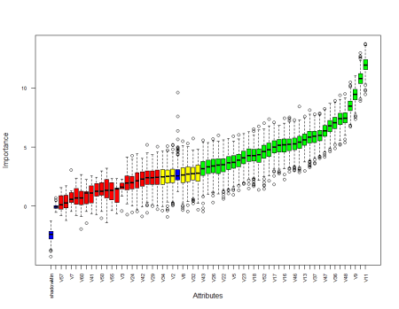

Blue box corresponds to shadow attributes, green color indicates important attributes, yellow boxes are tentative attributes and red boxes are unimportant.

plotImpHistory(boruta) 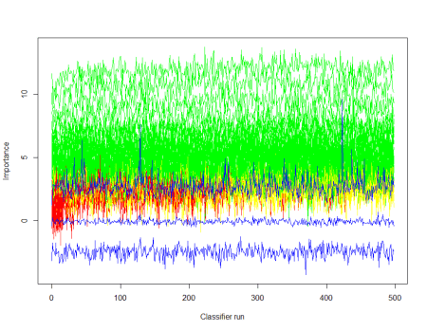

**Tentative Fix**

bor <- TentativeRoughFix(boruta)

print(bor)

Basically, TentativeRoughFix will take care of tentative attributes that are really important or unimportant and classified into accordingly.

Boruta performed 499 iterations in 1.3 mins.

Tentatives rough fixed over the last 499 iterations.

 35 attributes confirmed important: V1, V10, V11, V12, V13 and 30 more;

 25 attributes confirmed unimportant: V14, V2, V24, V25, V29 and 20 more;

attStats(boruta)

This will provide complete picture of all the variables.

meanImp medianImp  minImp maxImp normHits  decision

V1     3.63      3.66  1.0746    5.7    0.804 Confirmed

V2     2.54      2.55  0.0356    5.2    0.479 Tentative

V3     1.52      1.62 -0.4086    2.3    0.000  Rejected

V4     5.39      5.43  2.8836    8.4    0.990 Confirmed

V5     3.70      3.70  0.9761    5.9    0.814 Confirmed

V6     2.12      2.16 -0.4508    4.4    0.090  Rejected

V7     0.72      0.59 -0.4309    3.1    0.002  Rejected

V8     2.63      2.62 -0.3495    5.5    0.463 Tentative

.....................................................

V59    2.40      2.40 -0.5639    5.2    0.200  Rejected

V60    0.72      0.69 -1.9414    2.7    0.002  Rejected

**Data Partition**

Let’s partion the dataset into training dataset and test datasets. Now we want to identify the Boruta algorithm help the model to increase the accuracy.

set.seed(222)

ind <- sample(2, nrow(Sonar), replace = T, prob = c(0.6, 0.4))

train <- Sonar[ind==1,]

test <- Sonar[ind==2,]

Training dataset contains 117 observations and test data set contains 91 observations.

**Random Forest Model**

set.seed(333)

rf60 <- randomForest(Class~., data = train)

Random forest model based on all the varaibles in the dataset

Call: randomForest(formula = Class ~ ., data = train)

               Type of random forest: classification

                     Number of trees: 500

No. of variables tried at each split: 7

        OOB estimate of  error rate: 23%

Confusion matrix:

   M  R class.error

M 51 10        0.16

R 17 39        0.30

OOB error rate is 23%

**Prediction & Confusion Matrix – Test**

p <- predict(rf60, test)

confusionMatrix(p, test$Class)

Confusion Matrix and Statistics

          Reference

Prediction  M  R

         M 46 17

         R  4 24

               Accuracy : 0.769

                 95% CI : (0.669, 0.851)

    No Information Rate : 0.549

    P-Value [Acc > NIR] : 1.13e-05

                  Kappa : 0.52

 Mcnemar's Test P-Value : 0.00883

            Sensitivity : 0.920

            Specificity : 0.585

         Pos Pred Value : 0.730        \

         Neg Pred Value : 0.857

             Prevalence : 0.549

         Detection Rate : 0.505

   Detection Prevalence : 0.692

      Balanced Accuracy : 0.753

       'Positive' Class : M

Based on this model accuracy is 76%. Now let’s make use of the Boruta model.

getNonRejectedFormula(boruta)

Call: randomForest(formula = Class ~ V1 + V2 + V4 + V5 + V8 + V9 +      V10 + V11 + V12 + V13 + V15 + V16 + V17 + V18 + V19 + V20 +      V21 + V22 + V23 + V26 + V27 + V28 + V30 + V31 + V32 + V34 +      V35 + V36 + V37 + V39 + V43 + V44 + V45 + V46 + V47 + V48 +      V49 + V51 + V52 + V54, data = train)

               Type of random forest: classification

                     Number of trees: 500

No. of variables tried at each split: 6

        OOB estimate of  error rate: 22%

Confusion matrix:

   M  R class.error

M 52  9        0.15

R 17 39        0.30

Now you can see that the OOB error rate reduced from 23% to 22%.

p <- predict(rfboruta, test)

confusionMatrix(p, test$Class)

Confusion Matrix and Statistics

          Reference

Prediction  M  R

         M 45 15

         R  5 26

               Accuracy : 0.78

                 95% CI : (0.681, 0.86)

    No Information Rate : 0.549

    P-Value [Acc > NIR] : 3.96e-06

                  Kappa : 0.546

 Mcnemar's Test P-Value : 0.0442

            Sensitivity : 0.900

            Specificity : 0.634

         Pos Pred Value : 0.750

         Neg Pred Value : 0.839

             Prevalence : 0.549

         Detection Rate : 0.495

   Detection Prevalence : 0.659

      Balanced Accuracy : 0.767

       'Positive' Class : M

Accuracy increased from 76% to 78%.

getConfirmedFormula(boruta)

rfconfirm <- randomForest(Class ~ V1 + V4 + V5 + V9 + V10 + V11 + V12 + V13 + V15 + V16 +

                            V17 + V18 + V19 + V20 + V21 + V22 + V23 + V26 + V27 + V28 +

                            V31 + V35 + V36 + V37 + V43 + V44 + V45 + V46 + V47 + V48 +

                            V49 + V51 + V52, data = train)

Call:

 randomForest(formula = Class ~ V1 + V4 + V5 + V9 + V10 + V11 +      V12 + V13 + V15 + V16 + V17 + V18 + V19 + V20 + V21 + V22 +      V23 + V26 + V27 + V28 + V31 + V35 + V36 + V37 + V43 + V44 +      V45 + V46 + V47 + V48 + V49 + V51 + V52, data = train)

               Type of random forest: classification

                     Number of trees: 500

No. of variables tried at each split: 5

        OOB estimate of  error rate: 20%

Confusion matrix:

   M  R class.error

M 53  8        0.13

R 15 41        0.27

Now you can see that based on important attributes is OOB error rate is 20%.

**Conclusion**

Based on feature selection you can increase the accuracy of the model and if you are using neural network types of model can increase computational time also.